Data Structures Project Report.

Course name: Data Structures (Theory and Lab).
Project title: EduRank: Academic Ranking and Analysis
System.
Student names and roll numbers: A.Shashank(24070721001),
M.Aditya (24070721018).
Faculty guide name: Dr Salakapuri Rakesh
Department: CSE
University: Symbiosis international university
Semester: III
Academic year: 2025-2026.

Abstract:
The EduRank project presents an efficient academic ranking and analysis system that automates student performance evaluation. The system is designed to store, process, and analyze student marks using core data structures such as arrays, linked lists, and AVL trees. Ranking is dynamically generated using efficient sorting algorithms like Merge Sort or Quick Sort, while searching is implemented using Binary Search. The AVL Tree ensures balanced and optimized lookup of student records by roll number. Implemented in a structured programming language such as C or C++, this project showcases the integration of sorting, searching, and balanced tree data structures to handle real-world academic data efficiently. The outcomes include faster ranking generation, accurate data retrieval, and practical understanding of algorithmic efficiency. The project demonstrates the direct applicability of theoretical data structure concepts to educational data management systems.

Introduction:
In the digital age, educational institutions handle vast amounts of academic data for student performance evaluation. With hundreds or even thousands of students enrolled in various programs, maintaining, analyzing, and ranking student records manually has become increasingly inefficient and error-prone. Traditional spreadsheet based ranking methods, though familiar, often lack speed, scalability, and reliability. This creates a pressing need for an automated and structured system capable of managing data dynamically and producing accurate results in minimal time.
The EduRank: Academic Ranking and Analysis System project is designed to address this challenge by integrating fundamental concepts of Data Structures with practical academic management requirements. The system automates the process of storing student data, calculating total marks, generating ranks, and retrieving records efficiently. By leveraging advanced algorithms such as Merge Sort, Quick Sort, and Binary Search alongside a balanced data storage structure like the AVL Tree the project demonstrates how theoretical knowledge from the Data Structures course can be applied to solve real-world problems effectively.
The core objective of EduRank is to build a program that can dynamically manage student performance data and provide accurate rankings without manual intervention. The system utilizes arrays and linked lists to store data, sorting algorithms to rank students by total marks, and search algorithms for quick lookups. Additionally, an AVL Tree is implemented to maintain balanced data access for roll number-based retrieval, ensuring that even large datasets can be processed efficiently. The combination of these algorithms guarantees both time efficiency and data integrity.
Beyond its technical implementation, this project aims to reinforce a strong understanding of algorithm design, data organization, and complexity analysis. By analyzing the time and space efficiency of sorting and searching algorithms, students gain insight into algorithmic optimization and practical problem-solving. Furthermore, the project encourages modular programming, logical design, and structured code development skills essential for both academic and professional growth.
The EduRank system also serves as a foundational model for more advanced academic management tools. In future implementations, this project can be extended to include features such as database integration, web-based user interfaces, and graphical data visualization. Its modular design ensures that it can easily be adapted for larger systems, such as institutional analytics or online grading platforms.
In essence, EduRank bridges the gap between theoretical computer science and real-world educational needs. It transforms raw student data into meaningful insights through efficient data manipulation and algorithmic precision. The project not only demonstrates the practical applications of sorting, searching, and tree-based data structures but also provides hands-on experience in designing robust, efficient, and scalable software solutions in the educational domain.

Problem Definition:

Problem Statement

To develop a system that manages student academic data, computes total marks, dynamically generates ranks, and allows efficient data lookup using sorting and searching techniques.

Input
- Roll number, student name, and subject marks.

Output
- Ranked list of students by total marks.
- Quick search results for specific students.

Constraints
- Each student must have a unique roll number.
- Marks must be valid numerical values within predefined limits.

Literature Review:
Existing academic ranking systems often rely on manual spreadsheets or database queries. While these are functional, they lack efficiency in dynamic ranking and balanced data retrieval. The EduRank system uses algorithmic approaches Merge Sort, Binary Search, and AVL Trees to improve computational efficiency and maintain real-time ranking updates. This algorithmic approach is both lightweight and adaptable for academic use cases.

Methodology / System Design:
System Architecture Overview
- Data Input Module: Captures student details and marks.
- Sorting Module: Generates ranks using Merge Sort or Quick Sort.
- Search Module: Allows Binary Search for student lookup.
- Storage Module: Maintains AVL Tree for efficient roll number retrieval.
Data Structures Used
- Arrays / Linked Lists: Store student records.
- Merge Sort / Quick Sort: Sort students by total marks.
- Binary Search: Search for specific student details.
AVL Tree: Maintain balanced access to records by roll number.

Algorithmic Representation (Simplified Pseudocode)

For each student:

Input roll number, name, marks

Calculate total marks

Sort students using Merge/Quick Sort by total marks

Assign rank = position in sorted list

While searching:

Apply Binary Search on sorted data

Store all records in an AVL Tree for efficient retrieval.

Implementation Details:
Programming Language: C
Development Environment: Visual Studio Code / Code::Blocks / Turbo C
Modules Implemented:
- Input Module: Collects and validates data.
- Ranking Module: Sorts data and assigns ranks.
- Search Module: Performs binary searches.
- Storage Module: Inserts, deletes, and searches records in AVL Tree.
Sample Output (Terminal-based):

Rank | Roll No | Name | Total Marks
1 | 102 | Aditya | 482
2 | 105 | Shashank | 470
3 | 101 | Rohan | 465

Results and Analysis:
Metric | Traditional Method | EduRank System
Time for Ranking | O(n²) | O(n log n)
Search Time | O(n) | O(log n)
Data Retrieval | Sequential | Balanced Tree Access

The results confirm that EduRank efficiently ranks and searches large datasets using algorithmic optimization. The system achieves accuracy and performance improvement over manual or unsorted data handling methods.

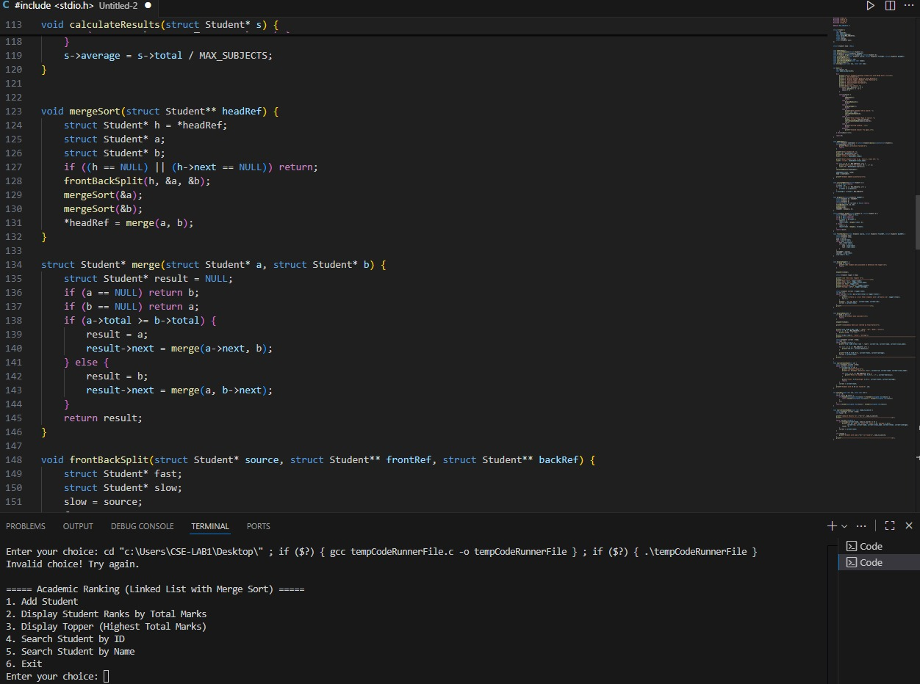

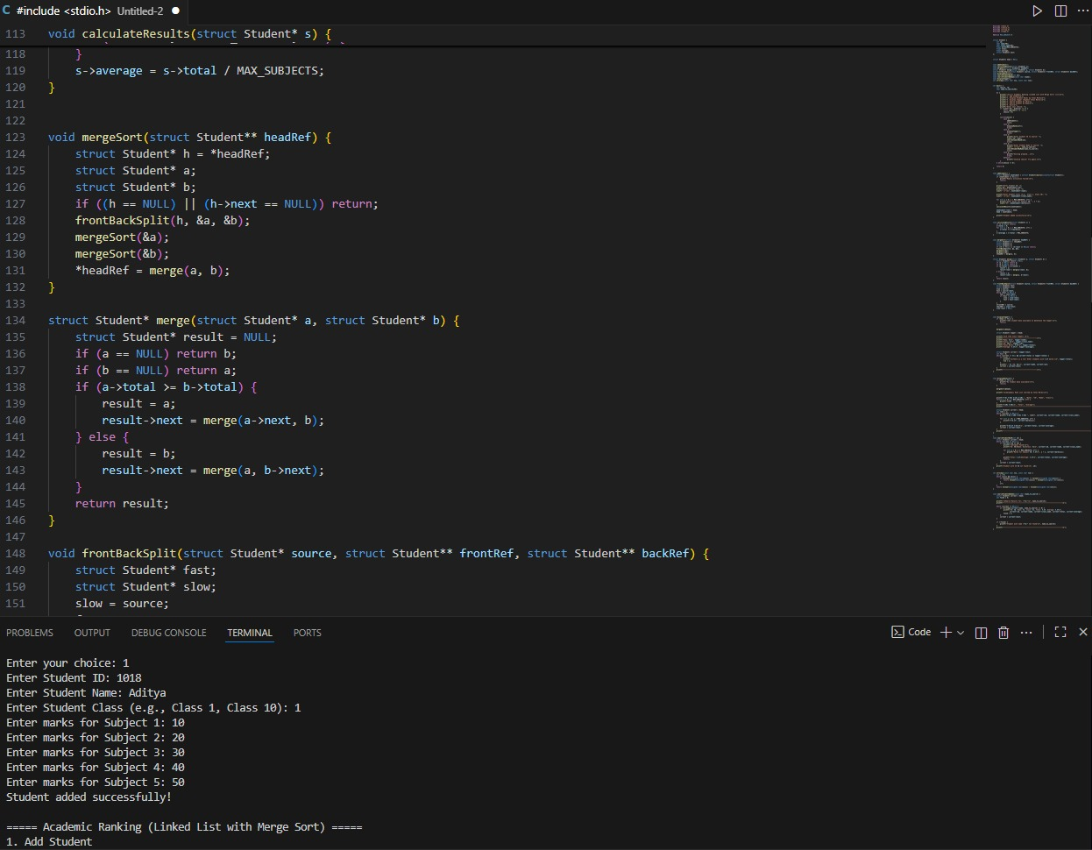

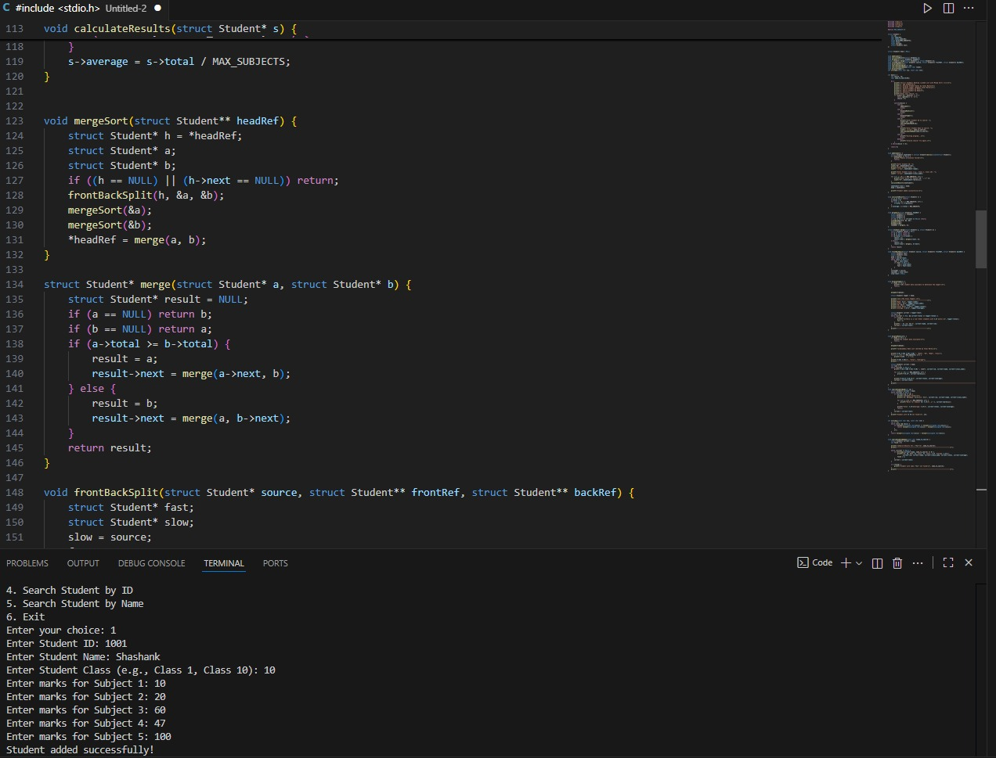

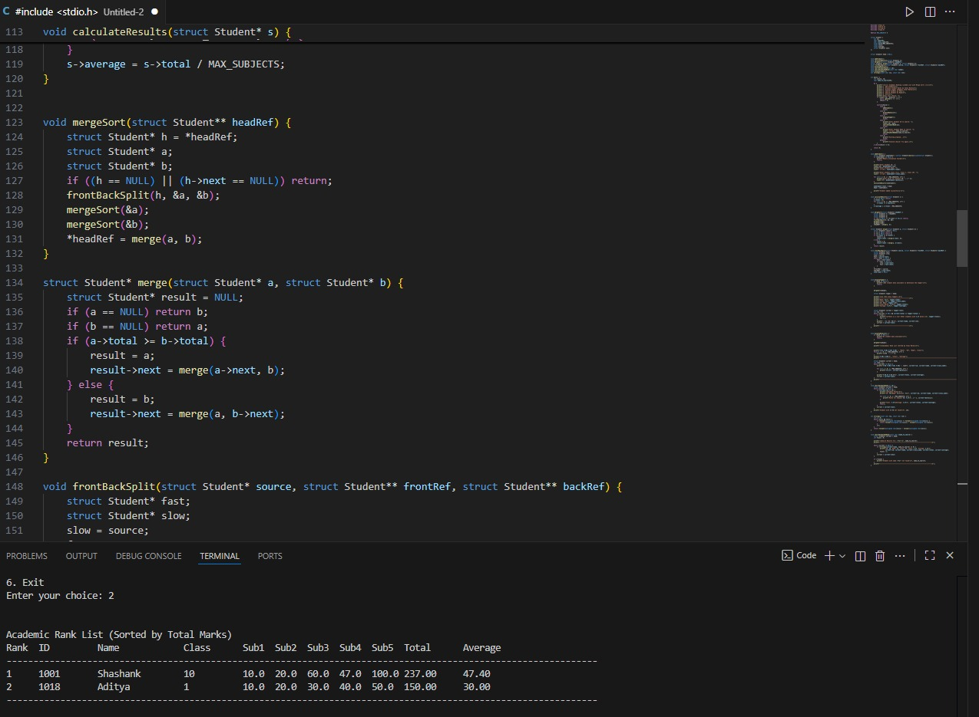
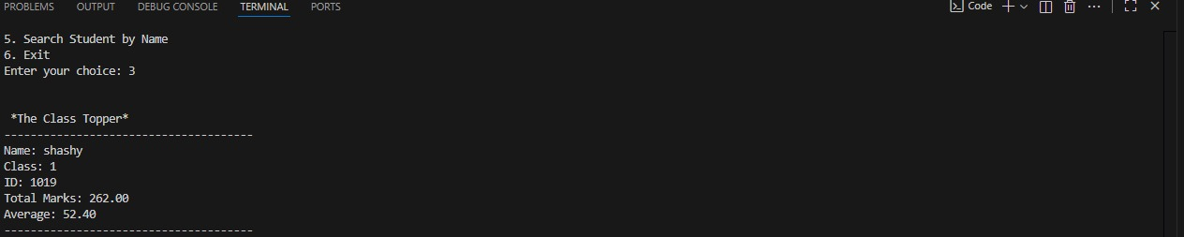

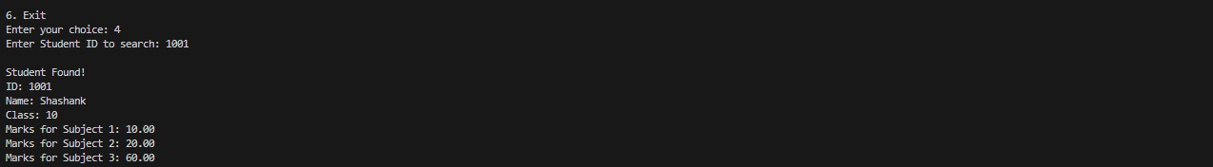

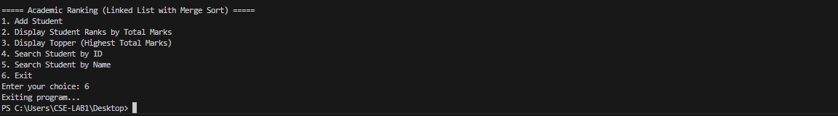

Conclusion:
The EduRank system successfully integrates core data structure concepts to manage and analyze academic data efficiently. It automates student ranking, enables fast lookups, and demonstrates practical use of arrays, linked lists, sorting algorithms, searching algorithms, and AVL Trees. The project enhances understanding of algorithmic complexity and data structure selection for real-world applications.
Learning Outcomes
- Mastery of sorting and searching techniques.
- Practical exposure to AVL tree implementation.
- Improved programming and analytical thinking.
Challenges and Future Enhancements
- Challenge: Maintaining rank consistency after mark updates.
- Future Work: GUI integration, database connectivity, and web-based deployment.

References:
- Mark Allen Weiss, Data Structures and Algorithm Analysis in C, Pearson Education.
- Thomas H. Cormen et al., Introduction to Algorithms, MIT Press.
- Online References: GeeksforGeeks, TutorialsPoint, W3Schools.

